YEAR 9 MEASUREMENT  NOTES BOOKLET | NAME:  YEAR 9 STANDARD MATHS 2020

Year 9 Measurement 2020

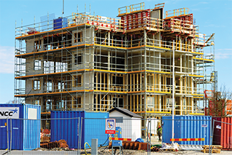
5A Length and Perimeter
Length is at the foundation of measurement from which the concepts of perimeter, circumference, area and volume are developed. From the use of the royal cubit (distance from tip of middle finger to the elbow) used by the ancient Egyptians to the calculation of pi (𝜋) by modern computers, units of length have helped to create the world in which we live.
* Courtesy of Year 9 Cambridge textbook.

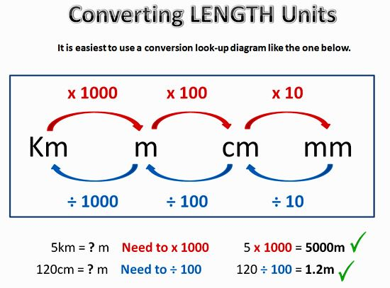

Example 1: Convert the measurements into the units given in brackets
a | 5 cm (mm) | b | 2.8 m (cm) | c 521 mm (cm)
d | 83.7 cm (m) | e | 4.6 km (m) | f 2170 m (km)

- Perimeter is the distance around the outside of
a closed shape.
  - Sides with the same markings are of equal length.
5 cm
P = 2 ⋅ 5 + 3
= 13 cm
3 cm

Example 2: Finding perimeter of simple shapes

18 m
6 cm 5 cm
3 cm
b
Find the perimeter of each of the following shapes.
a
12 m

Example 3: Find the Unknown length
4 m

5 m
Perimeter = 16 m
x m
Find the unknown side length in this shape with the given perimeter.

5B Circumference and Perimeter of a Sector
- Circumference is the length measured around a circle.
- A sector perimeter is a fraction of the length of a circle plus the two radii lengths where it has been segmented.
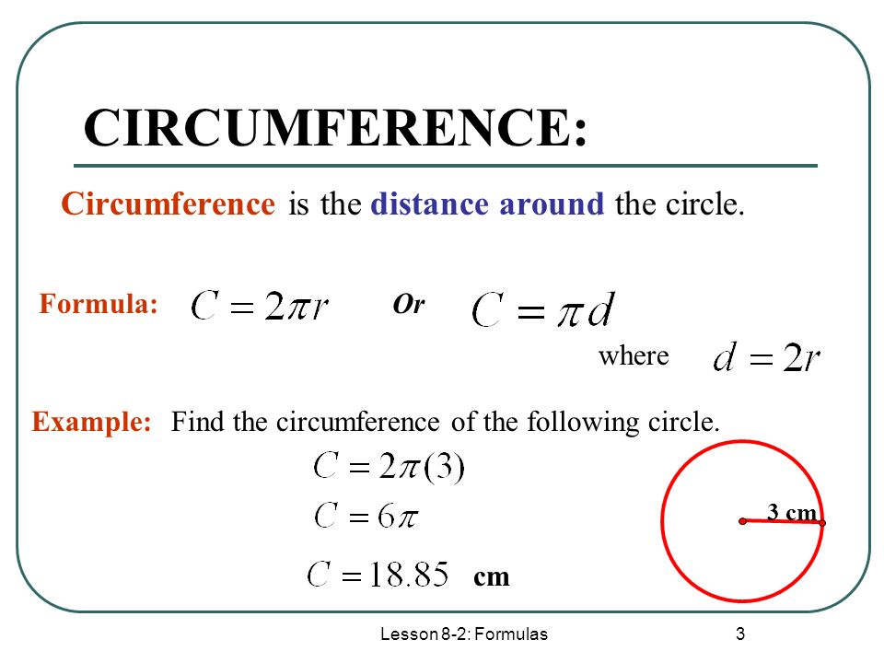
Example 4: Determine the fraction of the sector

Determine the fraction of a circle shown in these sectors. Write the fraction in simplest form.
a b c

60°
150°
225°

Example 5: Finding circumference and perimeter of sectors
Find the circumference of this circle and the perimeter of this sector correct to two decimal places.
a b
3 cm

100°
7 m

Example 6: Using exact values
4
2
Give the exact circumference/perimeter of these shapes.
a b

5C Area
- Below we can see which values to use when converting between units of area
- The second part shows the general formulas used to calculate the area for basic two dimensional shapes.

2
360
A = 1 xy
A = θ ⋅ π r2
A =πr2
x
r
θ
r
r
y
Sector
Circle
Kite
2
Area = 1(a + b)h
2
Area = 1 xy
a
x
h

b
Area = b ⋅ h
y
h
Rhombus
2
Area = 1 b ⋅ h
b

l
Area = l ⋅ w
Trapezium
b
Area = l2

Parallelogram
h
w
l
1 m2 = 1002 cm2
- The area of a two-dimensional shape is a measure of the space enclosed within its boundaries.
Square Rectangle Triangle
102 = 10 × 10 = 100
1002 = 100 × 100 = 10000
10002 = 1000 × 1000 = 1 000000
⎟102
⎟1002
mm2
cm2
m2
⋅102
⋅1002
⋅10002
km2
⎟10002
1 m = 100 cm
1 m = 100 cm

1 m2
- Conversion of area units

Example 7: Converting area measurements
Convert the following area measurements to the units given in the brackets.
a 859 mm2 (cm2) b 2.37 m2 (cm2)

11 km
1.5 cm
7 m
3 m
3 cm
c
5 km
a b
Find the area of each of the following plane figures.
Example 8: Finding areas of rectangles, triangles and parallelograms

Example 9: Finding areas of rhombuses and trapeziums
6 m
9 mm
4 m

3 m
b
10 mm
a
Find the area of each of the following plane figures.

Example 10: Finding areas of circles and sectors
Find the area of this circle and sector correct to two decimal places.
a b
260°
5.1 cm
4 m

5D Composite shapes
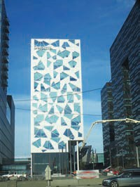
For this high-rise office building in Oslo, Norway, the architect has designed windows with triangular, trapezoidal and composite shapes.
- Composite shapes are made up of more than one basic shape.
- Addition and/or subtraction can be used to find areas and perimeters of composite shapes.
- The layout of the relevant mathematical working needs to make sense so that the reader of your work understands each step.

Example 11: Finding perimeters and areas of composite shapes
Find the perimeter and area of this composite shape, rounding answers to two decimal places.
17 cm

14 cm

5E Surface area of prisms and pyramids
- The total surface area (TSA) of a solid is the sum of the areas of all the surfaces.
- A net is a two-dimensional illustration of all the surfaces of a solid.
- A right prism is a solid with a uniform cross-section with two identical ends and the remaining sides are rectangles.
  - They are named by the shape of their cross-section.
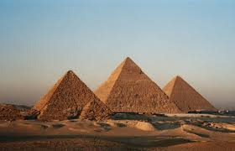

Example 12: Finding total surface area
Find the total surface area of this right rectangular prism and this right square-based pyramid.
a
b
2 cm
3 m
5 cm
3 cm
2 m
2 m

5F Surface area of a cylinder
2
- Surface area of a cylinder = 2 circles + 1 rectangle
= 2 ⋅ πr2 + πr ⋅ h
∴TSA = 2πr2 + 2πrh
r
h
2 circular ends curved area
- TSA = 21r2 + 21rh = 21r(r + h)
- In many problems, you will need to decide which parts of the surface of the cylinder should be included.
25 m
5 m
Find the surface area of this cylinder, rounding to two decimal places.
Example 13: Finding the surface area of a cylinder

Example 14: Finding surface areas of cylindrical portions
Find the total surface area of this half cylinder, rounding to two decimal places.

8 cm
4 cm

5G Volume of a Prism
- Common metric units for volume include cubic kilometres (km3), cubic metres (m3), cubic centimetres (cm3) and cubic millimetres (mm3).
⋅10003 ⋅1003 ⋅103
km3
m3
cm3
mm3
⎟10003 ⎟1003
⎟103
10003 = 1 000 000 000
1003 = 1 000 000
103 = 1000
- Common units of capacity include:
  - megalitres (ML) 1 ML 1000 kL
  - kilolitres (kL) 1 kL 1000 L
- litres (L) 1 L 1000 mL
- millilitres (mL)
- Also 1 cm3 = 1 mL so 1 L = 1000 cm3 and 1 m3 = 1000 L

Example 15: Converting volume units
Convert the following volume measurements to the units given in the brackets.
a 2.5 m3 (cm3) b 458 mm3 (cm3)

Example 16: Finding volumes of prisms and solids
6 cm
4 cm
1 cm
1 cm
3 cm
5 cm
Area =
10 cm2
3 cm
Find the volume of each of these three-dimensional objects.
a b c

5H Volume of a Cylinder
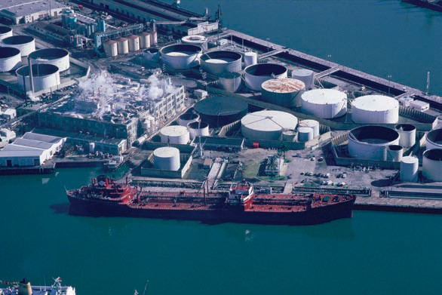
An oil refinery converts crude oil into many products including petrol, diesel, jet fuel, motor oils and asphalt base. Cylinder volumes are calculated for its storage tanks and
pipe capacity per m3.

r
h
- The volume of a cylinder is given by
V = r2 × h or V = r2h
  - r is the radius of the circular ends.
  - h is the length or distance between the circular ends.

Example 17: Finding the volume of a cylinder
0.3 m
10 cm
1.8 m
b
3 cm
a
Find the volume of these cylinders correct to two decimal places.

Example 18: Finding the capacity of a cylinder
Find the capacity, in litres, of a cylinder with radius 30 cm and height 90 cm. Round to the nearest litre.

Chapter 5: Measurement
Chapter checklist: Success criteria
 |  | ✔
5A | 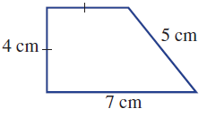  1. I can find the perimeter of simple shapes.  e.g. Find the perimeter of the following shape.  Ex 5A p. 299  Fluency 1, 2, 5(½), Problem-solving 7, 9, Reasoning 11(½), | ☐
5A | 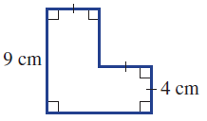  2. I can find the perimeter of composite shapes.  e.g. Find the perimeter of the following shape.  Ex 5A p. 299  Fluency 3, 4(½), 6de,  Problem-solving 8, 10, Reasoning, 12, Enrichment 14 | ☐
5B | 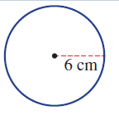  3. I can find the circumference of a circle.  e.g. Find the circumference of this circle both in exact form and rounded to two decimal places.  Ex 5B p. 305  Fluency 2, 5, Problem Solving 7, 8, Reasoning 12 | ☐
5B | 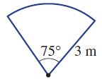  4. I can find the perimeter of a sector.  e.g. Find the perimeter of this sector correct to two decimal places.  Ex 5B p. 305  Fluency 3, 6(½), Reasoning 11def | ☐
5C | 5. I can convert between units of area.  e.g. Convert to and to .  Ex 5C p. 314  Fluency 2, Problem-solving 8 | ☐
5C | 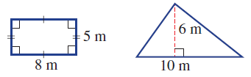  6. I can find the area of simple shapes.  e.g. Find the area of this rectangle and triangle.  Ex 5C p. 314  Fluency 3abc, Problem-solving 9, 10 | ☐
5C | 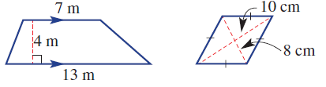  7. I can find the area of a trapezium or rhombus.  e.g. Find the area of the following trapezium and rhombus.  Ex 5C p. 314  Fluency 4(½), 5(½), Problem-solving 11 | ☐
5C | 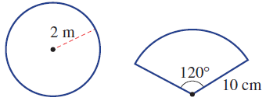  8. I can find the area of a circle or sector.  e.g. Find the area of this circle and sector correct to two decimal places.  Ex 5C p. 314  Fluency 6(½), Problem-solving 13, Reasoning 14/15 | ☐
5D | 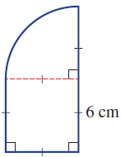  9. I can find the perimeter and area of composite shapes.  e.g. Find the perimeter and area of this composite shape, rounding answers to two decimal places.  Ex 5D p. 320  Fluency 1, 2(½), Problem-solving 6, 7, 9, Reasoning 12 | ☐
5E | 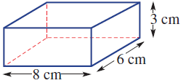  10. I can find the surface area of a prism.  e.g. Find the total surface area of this right rectangular prism.  Ex 5E p. 327  Fluency 1a, 2, Problem-solving 6, 7, 9, Reasoning 11, Enrichment 12 | ☐
5E | 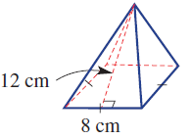  11. I can find the surface area of a pyramid.  e.g. Find the total surface area of this right square-based pyramid.  Ex 5E p. 327  Fluency 1b, 3 | ☐
5F | 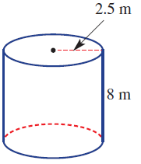  12. I can find the surface area of a cylinder.  e.g. Find the surface area of this cylinder correct to two decimal places.  Ex 5F p. 334  Fluency 1-5 (½), Problem-solving 8, Reasoning 10 | ☐
5F | 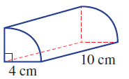  13. I can find the surface area of cylindrical portions.  e.g. Find the total surface area of this quarter-cylinder, rounding to two decimal places.  Ex 5F p. 334  Problem-solving 6 (½), Enrichment 12 | ☐
5G | 14. I can convert between units of volume.  e.g. Convert to and to .  Ex 5G p. 342  Fluency 2 (½) | ☐
5G | 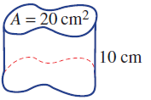  15. I can find the volume of an object with a constant cross-section.  e.g. Find the volume of this solid object.  Ex 5G p. 342  Fluency 4 (½), Problem-solving 8, Reasoning 10 | ☐
5G | 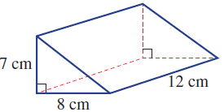  16. I can find the volume of a prism.  e.g. Find the volume of this triangular prism.  Ex 5G p. 342  Fluency 5 (½), Problem-solving 9, Reasoning 15 | ☐
5H | 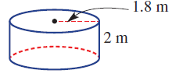  17. I can find the volume of a cylinder.  e.g. Find the volume of this cylinder correct to two decimal places.  Ex 5H p. 347  Fluency 2 (½) | ☐
5H | 18. I can find volume in terms of capacity.  e.g. Find the capacity in litres of a cylinder with radius 20 cm and height  80 cm. Round to the nearest litre.  Ex 5H p. 347  Fluency 3 (½), Problem-solving 4, 7(½) Reasoning 8 | ☐

