Pythagoras Theorem Revision Name: ___________________________

Question 1 (2 marks)
Mark in the Hypotenuse on the following Right Triangles

Question 2 (3 marks)
What is the length of the hypotenuse in the triangle below? Show to 1 decimal place.

15cm

6cm

h

Question 3 (3 marks)
What is the length of the hypotenuse in the triangle below? Show to 1 decimal place.
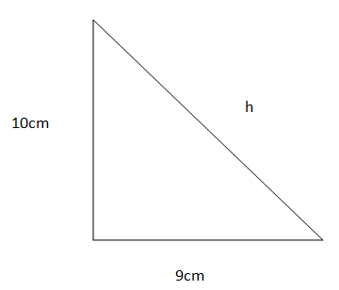

Question 4 (3 marks)
Find the length of the missing side (a)

8cm

10cm

a

Question 5 (1 mark)
In this right-angled triangle, circle which of the following statements is true?

A r² – q² = p²

B q² + p² = r²
C p² = q² – r² q p
D r² + p² = q²
E p² – q² = r²

r

Question 6 (3 marks)
What is the length of the diagonal (x) in a square with side length of 18 cm? (1 decimal place)

x

18cm

Question 7 (2 marks) if you show some working
The value of the pronumeral in this diagram is:

26

10

x

A 34.5
B 24.1
C 26.2
D 27.9
E 17.6

Question 8 (3 marks)
Find the value of the pronumeral (d) in this diagram. Correct to one decimal place.

18.6 cm

d

8.6 cm

Question 8 (3 marks)
Find the value of the pronumeral (a) Correct to one decimal place.

a

12 cm

16 cm

24 cm

Question 9 (3 marks) diagram & full working
Christiana walks diagonally from corner to corner in a rectangular field 56 m wide and 212 m long. How far does she walk?

Question 10 (3 marks)
diagram & full working
How tall is a flag pole if it is anchored 2.2 m from its base with a 9 m support wire? Correct to one decimal place.

Question 11 (3 marks)
Find the height of an isosceles triangle with equal sides of 25 cm and base of 22 cm. Correct to one decimal place.

/32

