***Pythagoras’ Theorem***Level 9 - Investigate Pythagoras’ Theorem and its application to solving simple problems involving right angled triangles

Hundreds of years ago a man named Pythagoras observed a particular pattern in the floor tiles in a building. He discovered that if you take the square of the longest length (hypotenuse) it will be equal to the addition of the squares of the shorter two sides.

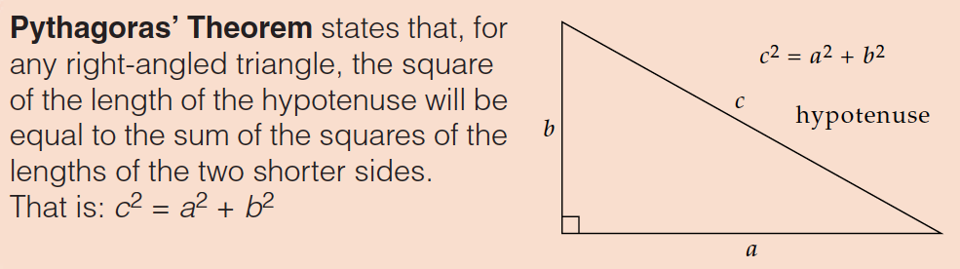

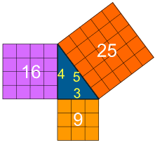



Pythagoras’ Theorem can be used to help find an unknown side length when the other two side lengths are known. Note that it does not matter which side you call ***a*** and which one ***b***

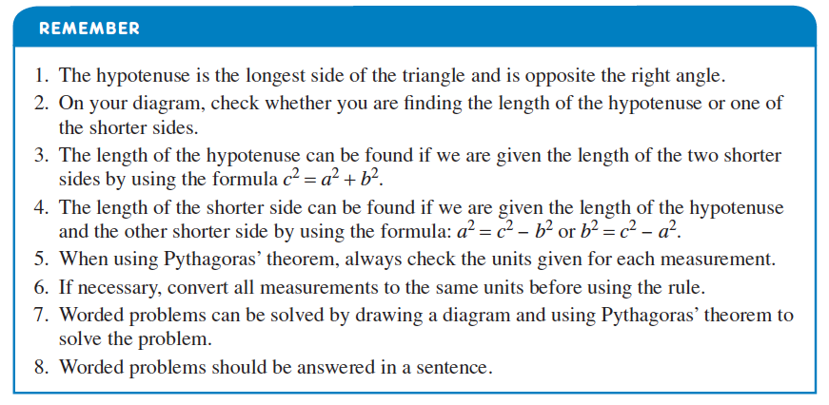

**1A – Finding the unknown hypotenuse (the longest side)**

So long as the two shorter sides a known, the longest side in a right angled triangle can be easily found using Pythagoras’ Theorem.

**Worked Problem:** Find the unknown in each of the following.

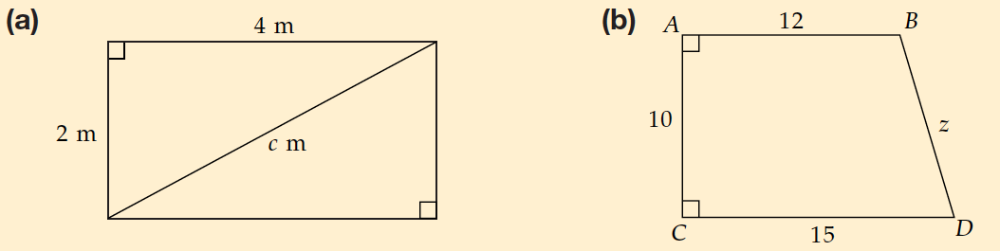

**1B – Finding one of the unknown shorter sides**

**Worked Problem:** Find the unknown in each of the following.

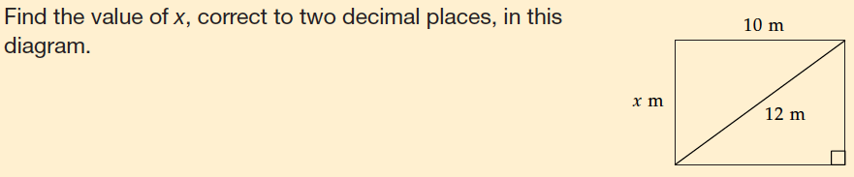

**1C – Applications of Pythagoras’ Theorem**

Right angled triangles are found in many situations, and so Pythagoras’ Theorem is often useful for calculations based around these triangles.

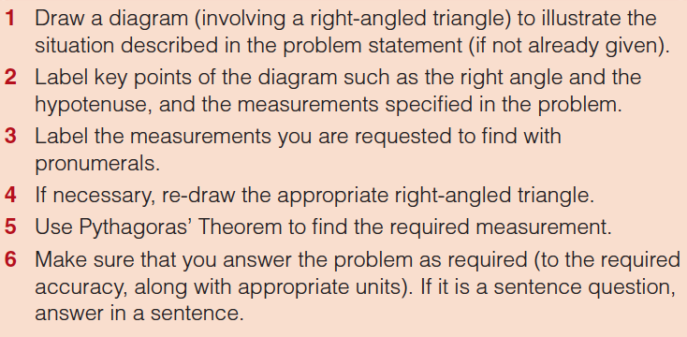

**Worked Problem:**

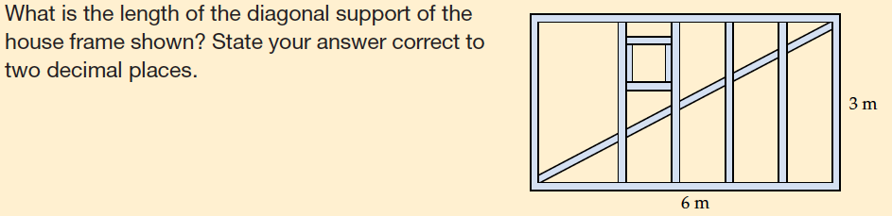

**Worked Problem:**

