NAME:

Yr 9 2020 Pre-General Expanding and Factorising Checklist
Pre-Test | Teacher resource
2A Expanding Algebraic Expressions
p. 80 in textbook
2C Expanding Algebraic Expressions  p. 91 | - Write out the distributive law.  - Find 2 different maths sites that have a video tutorial that you can view.  - Record the sites and pathway to the video.
Exercise 2C  p. 94 | Exercise 2C Q2-6 efgh Q7-8 abc  Q11 ace Q12 abef
EXTENSION: Text pg 94/5 | Q8 def, Q13,
8A Expanding Binomial Products
p. 502 | - Read through and record the Distributive Law (FOIL) Eg (a+b)(a-b)  - Revisit the maths sites you found to view a video on expanding Binomials (double brackets)  Or go to You tube: https://youtu.be/Wc2cgGU2I08
Exercise 8A  p. 504 | Exercise 8A Q1 all Q2-3 adgj,  Q4 all Q8 acegi
Problem Solving pg 505 | Exercise 8A Q 6 or 7
EXTENSION: Text pg 505 | Exercise 8A Q 10-11
8B Perfect Squares and the Difference of Perfect Squares p. 506
You tube video: https://youtu.be/ZyvVcRRhDo4
p. 507 | - Building Understanding
Exercise 8B | Q1 all Q3 -6 LHS
Reasoning pg 505 | Exercise 8B Choose 2 of 8, 9 10 or 11
EXTENSION: Text pg 505 | Exercise 8B Q 12 as many as you can.

8C Factorising Algebraic Expressions
- You tube Factoring Video: https://youtu.be/3DMFb_7m6mo
p. 512 | - Building Understanding
Exercise 8C  p. 514 | Q3-4 LHS and RHS  Q5 adgj Q6 as many as you can
Reasoning pg 516 | Exercise 8C Q 11-12
EXTENSION: Text pg 516 | Exercise 8B Q 13 as many as you can.
8D Factorising the Difference of Perfect Squares
pp. 517-8 | - Lesson Starter and Building Understanding
p. 519 | Exercise 8D Q1 all Q2-4 LHS  Q5 as many as you can
Problem Solving p. 520 | Exercise 8D Q 6 - 7
8E Factorising by Grouping
You tube video lesson: https://youtu.be/DBoiHLOdhmw
p. 522 | Read through Key Ideas and examples
Exercise 8E | Q1 all Q2-4 LHS  Q5 as many as you can
For students doing Pre- Methods:
8F Factorising Quadratic Trinomials

- You Tube video lesson : https://youtu.be/_lSGP8wYKC4
p. 527 | - Read Key Ideas and complete Building U/standing
Exercise 8F | Q1 all Q2-6 LHS
Reasoning p. 529 | Exercise 8F Q 9-10
EXTENSION: Text pg 529 | Exercise 8F Q 11 as many as you can.
Text p. 530 | PROGRESS QUIZ
Revison p. 561 | Chapter Review Q1-6 all
TEST

2A & 2C Expansion

For a single term outside of a bracket, multiply the term by each term inside the bracket.

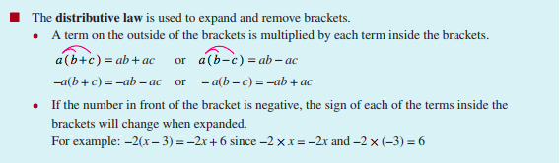
Example

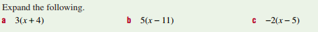

Example

Exercise 2C Q2-6 efgh Q7-8 abc
Q11 ace Q12 abef
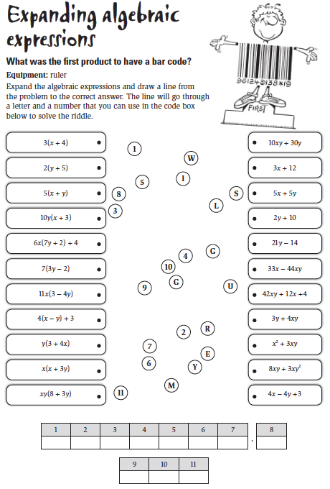
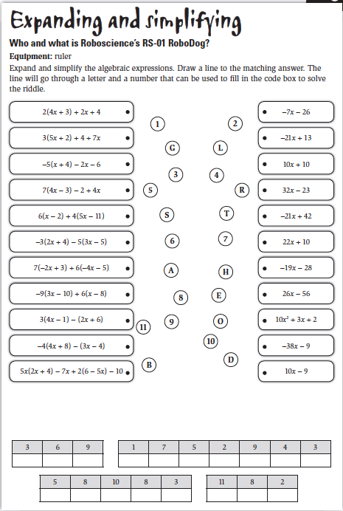

8A Expanding Two Brackets (binomial expansion)

To expand a pair of brackets, multiply each of the terms in the first bracket with each of the terms in the second bracket.

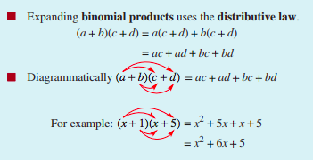

Example

Exercise 8A Q1 all Q2-3 adgj,
Q4 all Q8 acegi
Exercise 8A Q 6 or 7

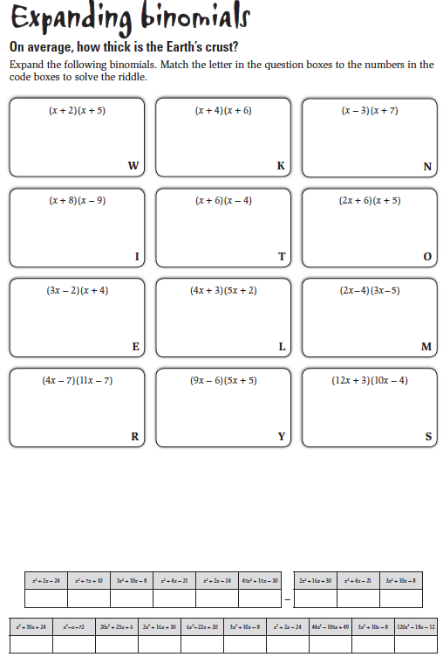

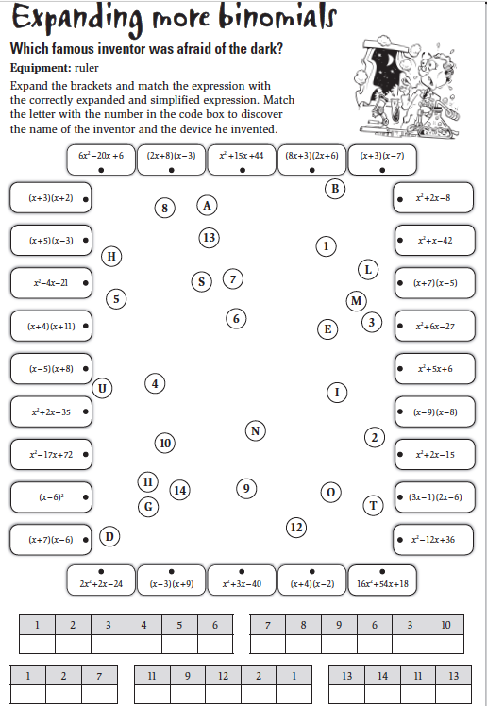

8B Expanding Perfect Squares and Difference of Perfect Squares (DOPS)

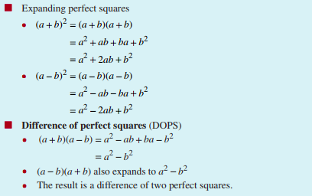 Example

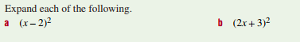

Example

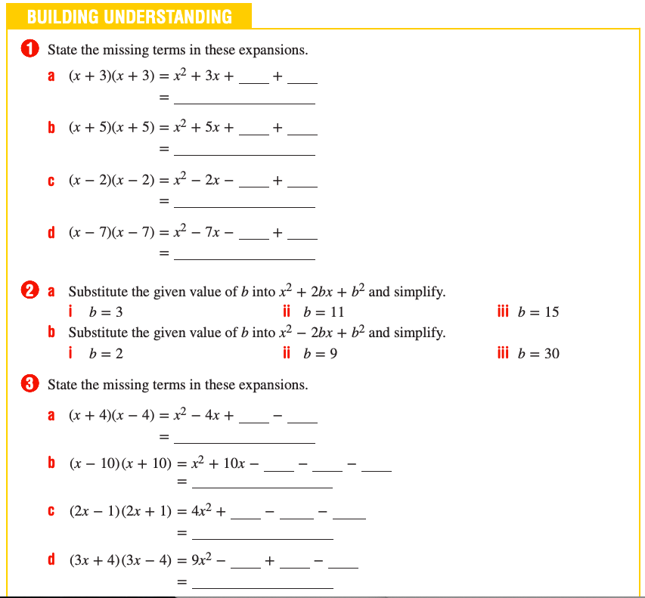

Exercise 8B Q1 all
Q3 -6 LHS
Exercise 8B Choose 2 of 8, 9 10 or 11

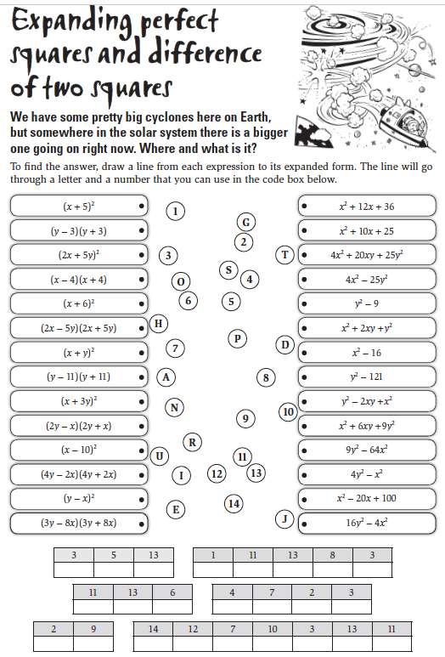

8C Factorising Algebraic Expressions
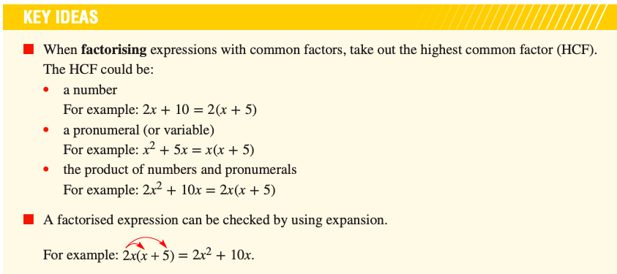

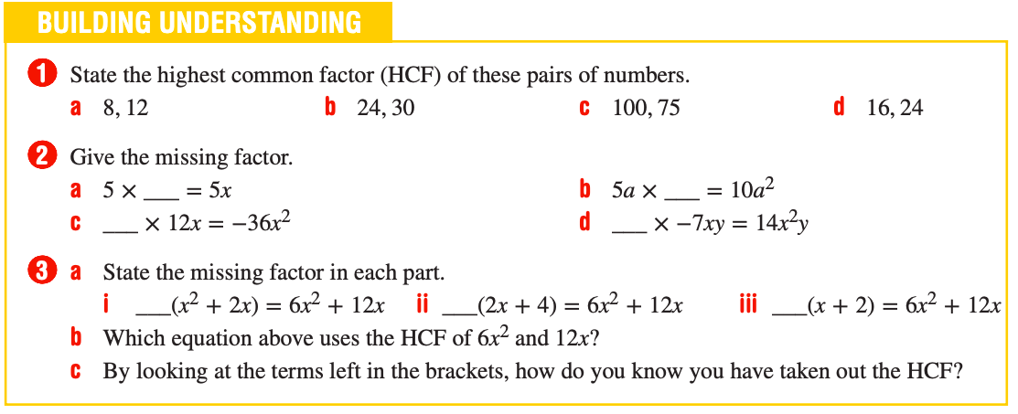

Exercise 8C Q3-4 LHS and RHS
Q5 adgj Q6 as many as you can
Exercise 8C Q 11-12

8D Factorising Using DOPS
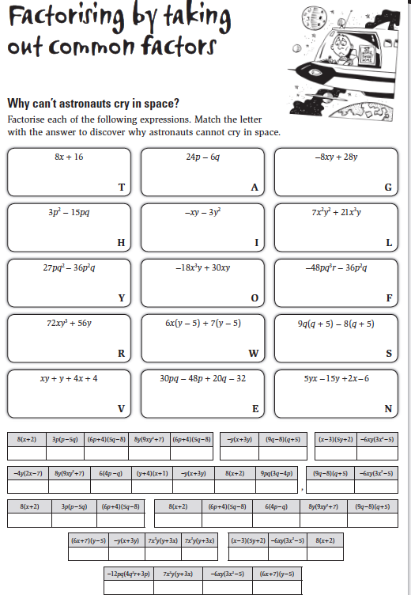

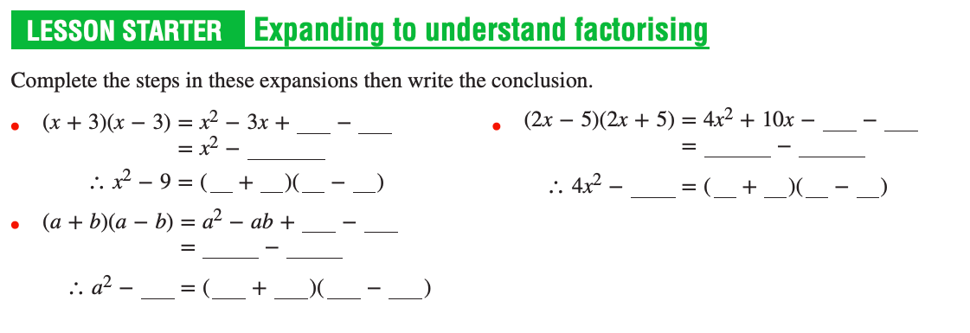
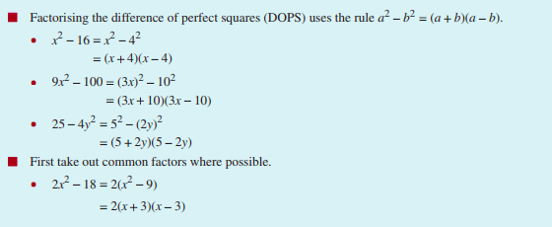

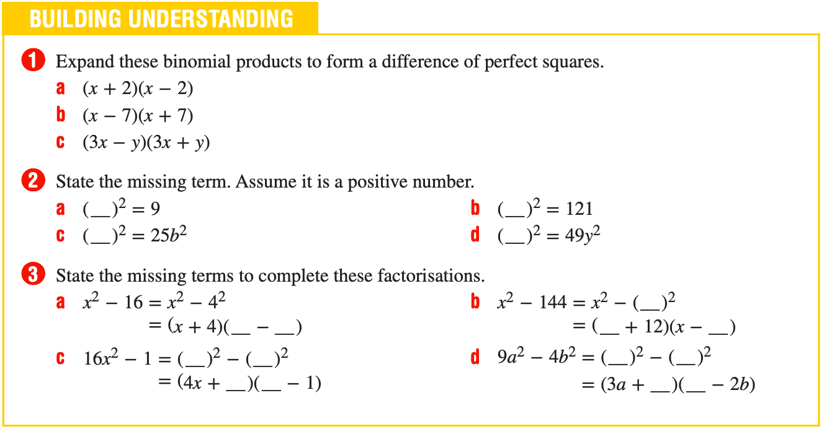

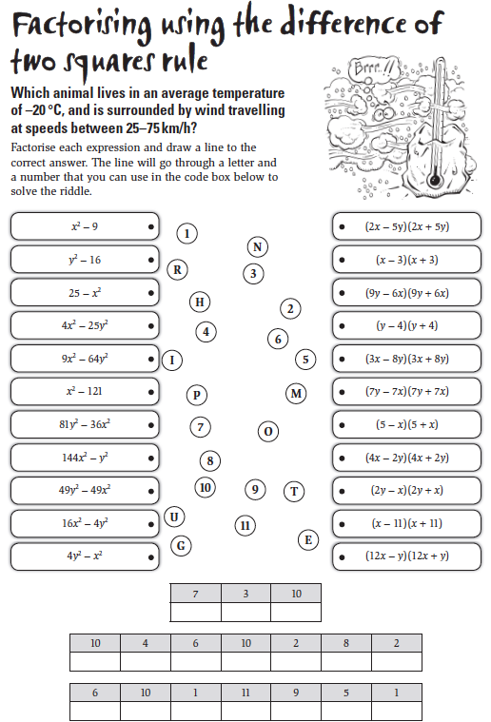

Examples
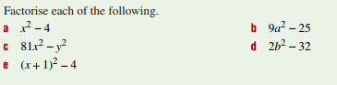

Exercise 8D Q1 all Q2-4 LHS
Q5 as many as you can
Exercise 8D Q 6 - 7

8E Factorising by Grouping

Use the link to watch a video to improve your understanding
https://youtu.be/DBoiHLOdhmw

factor by grouping polynomials?
(i) ar + br + at + bt
(ii) x² - ax - bx + ab
(iii) ab² - bc² - ab + c²
(iv) x² - xz + xy - yz
(v) 6ab - b² + 12ac - 2bc

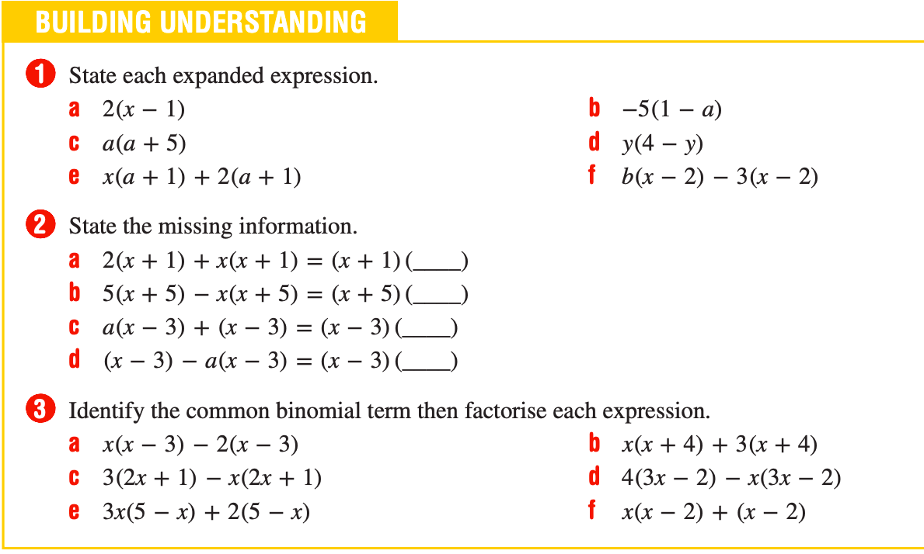

Exercise 8E Q1 all Q2-4 LHS
Q5 as many as you can

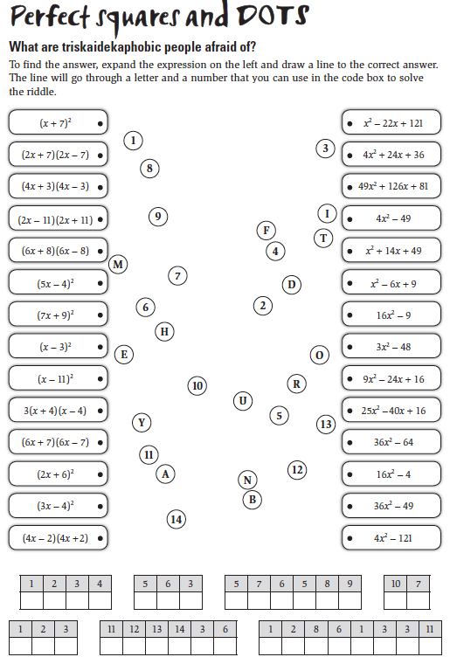

Pre Methods Students: 8F Factorising Quadratic Trinomials

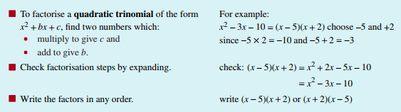

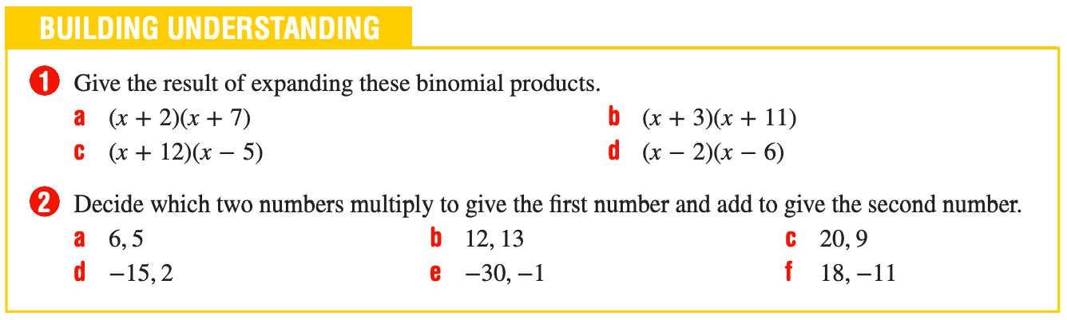

Examples

Exercise 8F Q1 all Q2-6 LHS
Exercise 8F Q 9-10
Exercise 8F Q 11 as many as you can.

