Name_____________________
Year 9 2020
Linear Relations

4A Introduction to Linear Relations

The Cartesian Plane:
- A Cartesian plane consists of two axes.
  - The horizontal axis is called the x-axis
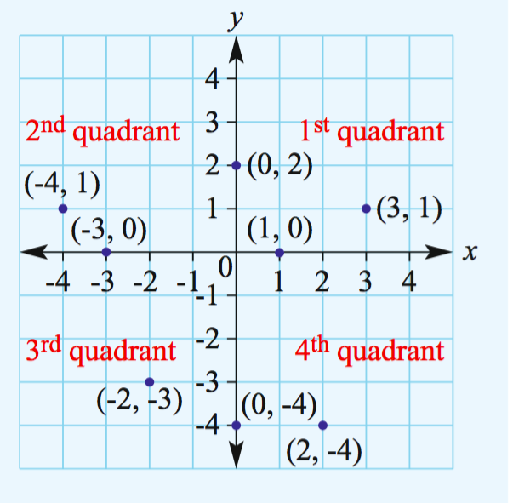
  - The vertical axis is called the y-axis.

- The centre of a Cartesian plane is called the origin.

- A Cartesian coordinate is written as (x, y),

Eg. (-4, 1) means the coordinate is positioned at x=-4 and y=1
Hint: To locate a point on the Cartesian plane, move along the x-axis to the number indicated by the x-coordinate and then along the y-axis to the number indicated by the y-coordinate.
For example, to locate the point with coordinates (1, 2), move 1 unit to the right of the origin and then 2 units up.

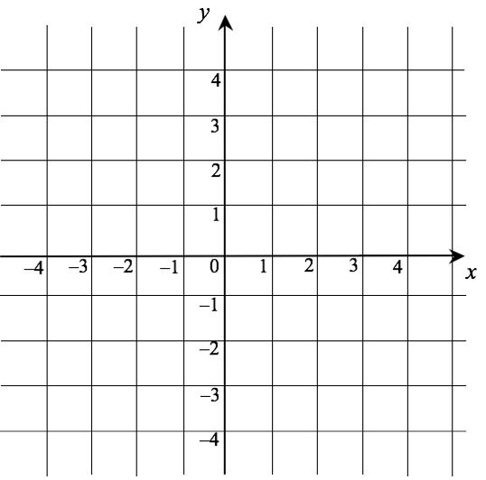
Example 1:
Plot the following points onto the Cartesian Plane

- Plot: (3,4), (-2, 4), (-2, -3), (3, -3), (3,4)

- Using a ruler, join the points in order.

- What shape has been formed?

Linear Relations:

- A Linear Relation is a set of ordered pairs (x,y) that when graphed give a straight line.

Screencast.
https://cambridgemaths.cambridge.edu.au/link/f1bf9ee429b4e4f5756bac90c9be50a4

Example 2:
Using $-3≤x≤3$ construct a table of values and plot a graph for $y=x+2$

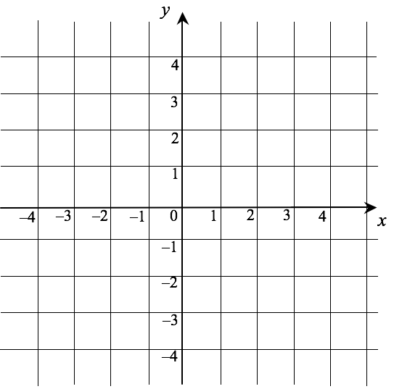

x | -3 | -2 | -1 | 0 | 1 | 2 | 3
y

Example 3:
Using $-3≤x≤3$ construct a table of values and plot a graph for $y=-2x+2$

x | -3 | -2 | -1 | 0 | 1 | 2 | 3
y

X and y intercept:

- The x intercept is where the graph cuts the x axis
- The y intercept is where the graph cuts the y axis

These intercepts can be found from a graph or from a table of values.

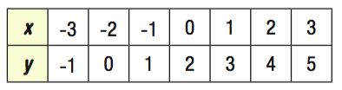
Table of values:
x intercept is located where y=0
x intercept = (-2, 0)

y intercept is located where x=0
y intercept = (0, 2)

Graph:
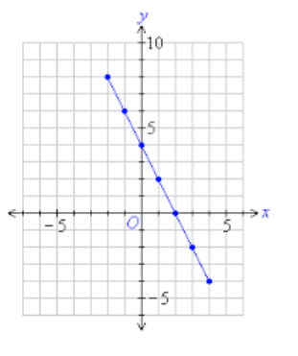

y intercept is located where x=0

y intercept = (4, 0)

x intercept is located where y=0

x intercept = (2, 0)

Screencast.
https://cambridgemaths.cambridge.edu.au/link/4e39b930823ce39e1384991d70da28b7

Example 4:
Write down the x and y intercept from this table

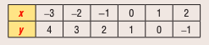

Example 5:
Write down the x and y intercept from this graph

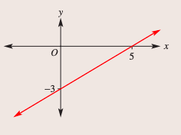

Decide if a point is on a line:

- Sometimes we want to see whether a particular coordinate is on the line that a linear relation forms.

Screencast. https://cambridgemaths.cambridge.edu.au/link/94c5316f3f5f6b24d68a08d057dbcbd7

Example 6:
Decide if the point (-2,4) is on the line with the given rules:

- $y=2x+10$

- $y=-x+2$

4B Graphing straight lines using intercepts

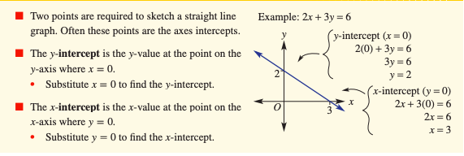

Screencast.
https://cambridgemaths.cambridge.edu.au/link/baeb4aa07049d820252a87d4ee203855

Example 1:
Sketch the graph of the following, showing the x and y intercepts.

- $2x+3y=6$

- $y=2x-6$

4C Graphing straight lines using intercepts

Vertical Lines:
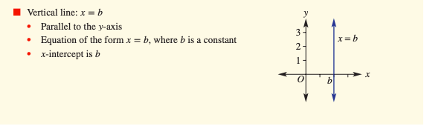

Horizontal Lines:
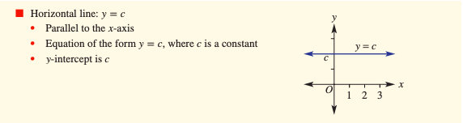

Screencast.
https://cambridgemaths.cambridge.edu.au/link/af8c76e370440a0098a67b1f210afc88

Example 1:
Sketch the graph of the following horizontal and vertical lines
- $y=3$

- $x=-4$

Lines through the Origin:
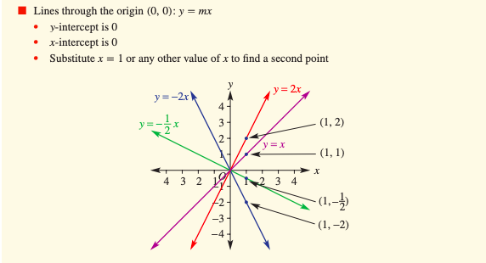

Screencast.
https://cambridgemaths.cambridge.edu.au/link/7229b6272164ccbc7cb0139057db0d7c

Example 2:
Sketch the graph of $y=3x$

4D Gradient
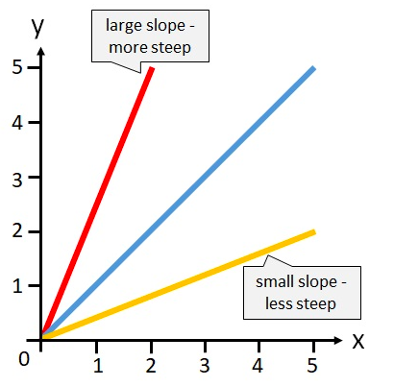
- The gradient/slope of a line
is a number that describes the steepness of the line.

- The larger the gradient, the steeper the line.

- Specifically, gradient measures the vertical increase/decrease for every unit moved right.

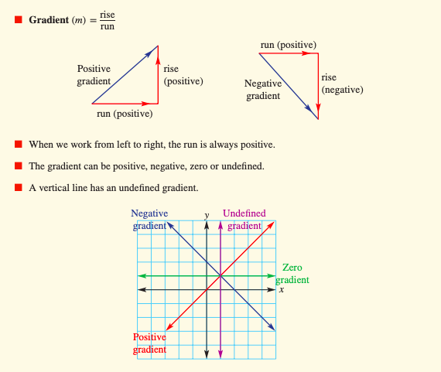
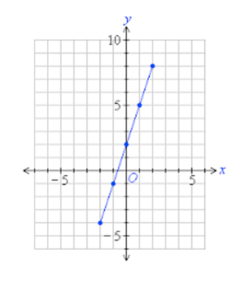
How to find the gradient from a graph:

- Choose two points on the line

(1,5)

(-1,-1)

- Calculate the vertical distance between the two points (rise).

Rise from -1 to 5
Rise = 6

- Calculate the horizontal distance between the two points (run).

Run from -1 to 1
Rise = 2

- Gradient (m) = $\frac{rise}{run}$ m = $\frac{6}{2}$ m = 3

Screencast.
https://cambridgemaths.cambridge.edu.au/link/ef33469c7aa3c7758bd61423b19a7c20

Example 1:
For each graph, state whether the gradient is positive or negative, and find the gradient if possible.
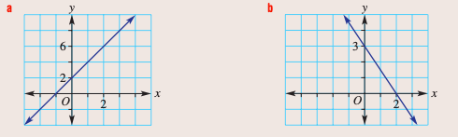

How to find the gradient from two coordinates:

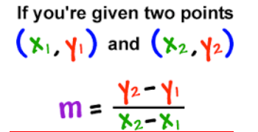

Screencast.
https://cambridgemaths.cambridge.edu.au/link/e6de2542a78a0fe1bc4a6e00889fa2de

Example 2:
Find the gradient (m) of the line joining the given points.
- A(3,4) and B(5,6)

- A(-3,6) and B(1,-3)

4E Gradient and direct proportion

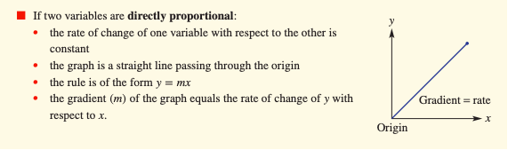

Screencast.
https://cambridgemaths.cambridge.edu.au/link/2a7b4f5b86c4b735137bf5acc5e68189

Example 1:
Water is poured into an empty tank at a constant rate. It takes 3 hours to fill the tank with 6000 litres.
- What is the rate at which water is poured into the tank?

- Draw a graph of Volume (V litres) vs Time (t hours) using $0≤t≤3$

- Find:
- The gradient of your graph

- The rule for V.

- Use your rule to find:
- The volume after 1.5 hours

- The time to fill 5000 litres
4F The ‘gradient-intercept’ form

- An equation is usually written in what’s known as ‘gradient-intercept’ form.
- This is a form of the equation where both the gradient and the y intercept can be found via inspection.
$$y=5x+2$$

y intercept = 2
gradient = 5

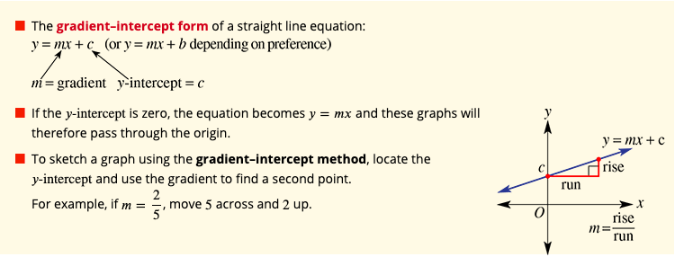

Finding the gradient and y intercept from inspection:

Screencast.
https://cambridgemaths.cambridge.edu.au/link/a3dcc1094f89c9604c3a66c418b0c23d

Example 1:
State the gradient and the y intercept for the graphs of the following relations:
- $y=2x+1$

- $y=-3x$

Rearranging equations

Screencast.
https://cambridgemaths.cambridge.edu.au/link/4d12ee3c7e4ab601596c76900b6f8bdb

Example 2:
Rearrange these linear equations into the form shown in brackets.
- $4x+2y=10$ ($y=mx+c$)

- $y=4x-7$ ($ax+by=d$)

Sketching graphs using the y intercept and gradient

Screencast.
https://cambridgemaths.cambridge.edu.au/link/4d12ee3c7e4ab601596c76900b6f8bdb

Example 3:
Find the gradient and the y intercept for these relations, and sketch their graphs.
- $y=2x-1$

- $x+2y=6$

4G Finding the Equation of a line

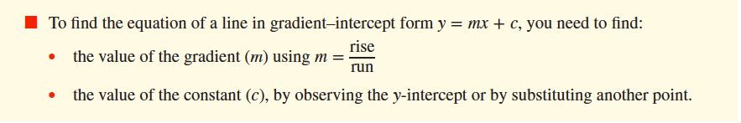

Screencast.
https://cambridgemaths.cambridge.edu.au/link/a7409316ad5592f8ca4447bc81d9a1c3

Example 1:
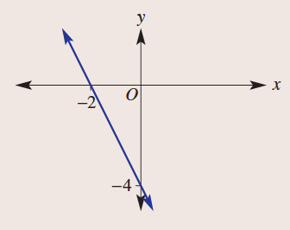
Determine the equation of the linear relation shown here:

Screencast.
https://cambridgemaths.cambridge.edu.au/link/5f9ab228322afbccd42fd6b95bc01fe6

Example 2:
Find the equation of a line that has a gradient of $\frac{1}{3}$ and passes through the point (-3,4).

4H Midpoint and length of a line segment

Midpoint

- The midpoint between any two coordinates ($x_{1},y_{1}) and (x_{2},y_{2})$is given by:
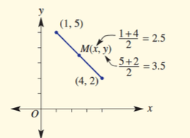
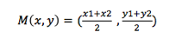

Screencast.
https://cambridgemaths.cambridge.edu.au/link/7366711a2a8fa163b1b894acdd19332c

Example 1:
Find the midpoint of the line segment joining the following set of coordinates:

- (1,0) and (4,4)

- (-3,-2) and (5,3)

Length of a Line Segment

- The distance between any two coordinates (x1, y1) and (x2, y2) is given by:

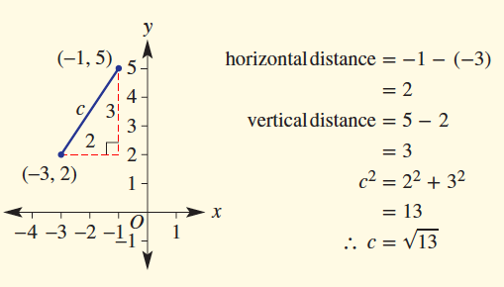
This formula is an application of Pythagoras’ theorem which we investigated earlier in the year.
Effectively, we are making a right-angle triangle with the distance between the two points representing the hypotenuse.

Screencast.
https://cambridgemaths.cambridge.edu.au/link/f0ad1520b133ef82f870c982793ef352

Example 2:
Find the length of the line segment joining (-2,2) and (4,-1), correct to two decimal places.

4I Perpendicular and Parallel Lines
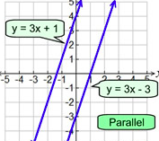
Parallel Lines

- If any two lines are parallel, then they will have the same gradient.

Screencast.
https://cambridgemaths.cambridge.edu.au/link/ed40f6c14eebd0da2d890c6a639be475

Example 1:
Find equation of a line that is parallel to $y=3x-1$ and passes through the point (0,4)

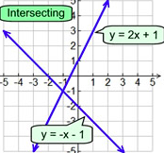
Perpendicular Lines

- If two perpendicular lines (lines that intersect) have gradients gradients of $m_{1} and m_{2}$ then:

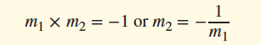

Screencast.
https://cambridgemaths.cambridge.edu.au/link/924bede9979cb2595c3f703da4584aec

Example 2:
Find the equation of a line that is perpendicular to
$y=2x-3$ and passes through (0,-1)

4J Linear Modelling

- In this section, we will look at some practical situations using linear graphs and their equations.
- This will involve interpretation of worded problems and the application of skills used in the previous exercises.
- Please make sure that you use your highlighter when tackling these questions.

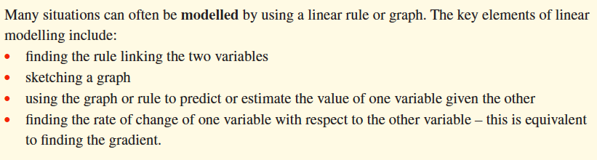

Screencast.
https://cambridgemaths.cambridge.edu.au/link/a07080f1fbf8da21859a41d5a7fed451

Example 1:
The deal offered by Netshare, an internet provider, to its new customers is a fixed charge of $20 per month plus $5 per hour of use.

- Write a rule for the total monthly cost, $C, of using Netshare for t hours per month

- Sketch the graph of $C versus t using $0≤t≤10$.

- What is the total cost in a month when Netshare is used for 4 hours?

- If the monthly cost was $50, for how many hours was Netshare used for the month?
4k Graphical solutions to simultaneous equations

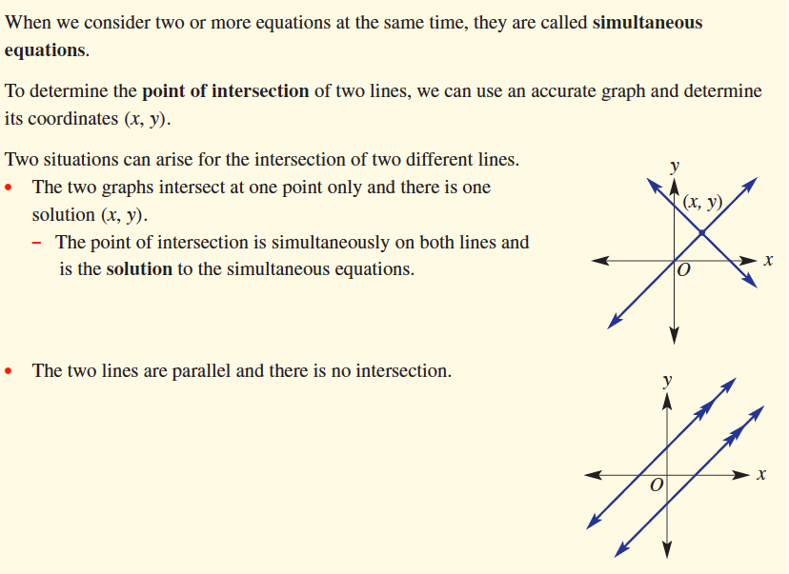

Screencast.
https://cambridgemaths.cambridge.edu.au/link/cb9198549f09a763be46ed29d74b6b09

Example 1:
Decide if the given point is at the intersection of the two lines with the given equations.

- $y=2x+3 and y=-x$ with the point (-1,1)

- $y=-2x and 3x+2y=4$ with the point (2,-4)

Screencast.
https://cambridgemaths.cambridge.edu.au/link/b0800ac00dd066be2ebb337d5b5f77d7

Example 2:
Solve the simultaneous equations $y=2x-2 and x+y=4$ graphically.

Summary Sheet
- Put your own hints and tips into the table below.

