Pythagoras’ Theorem in 3D - Extension

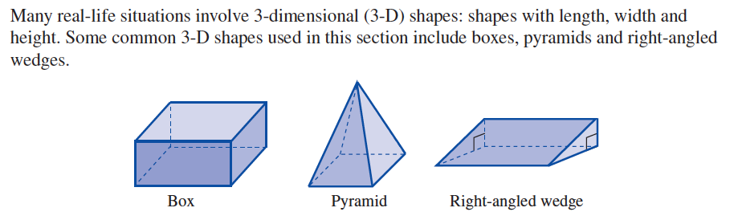
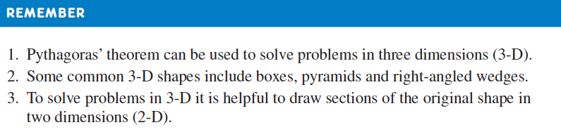

Worked Problem

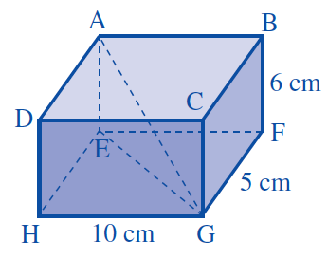
Find the length AG

Exercises

Question 1:
Calculate the length AG in each of the following
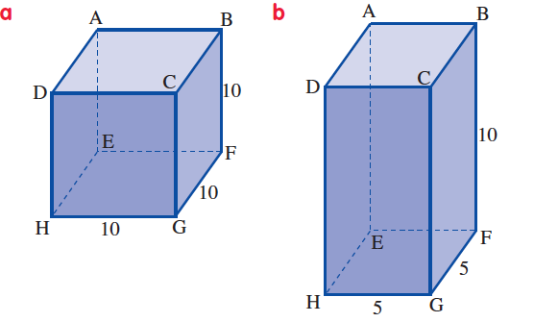

Question 2:
Calculate the length of CE in the wedge, and then AC.
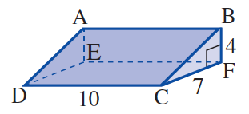

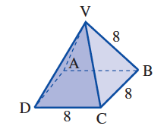
Question 3:
Calculate the length of BD and then the height of the pyramid.

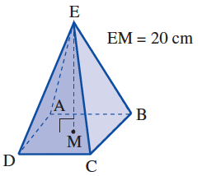
Question 4:
Pyramid ABCDE has a square base. The pyramid is 20cm high. Each sloping edge measures 30cm. Calculate the length of the sides of the base.

Question 5:
The sloping side of the cone is 10cm and the height is 8cm. What is the length of the radius of the base?
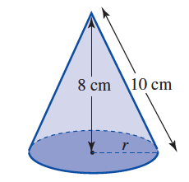

Question 6:
